Fragments GitHub Link
https://github.com/MansoorAZafar/fragments
Dockerfile
https://github.com/MansoorAZafar/fragments/blob/main/Dockerfile
.dockerignore
https://github.com/MansoorAZafar/fragments/blob/main/.dockerignore

Fragments Microservice running docker container detached, using port 5555 localhost and 8080 container & docker logs
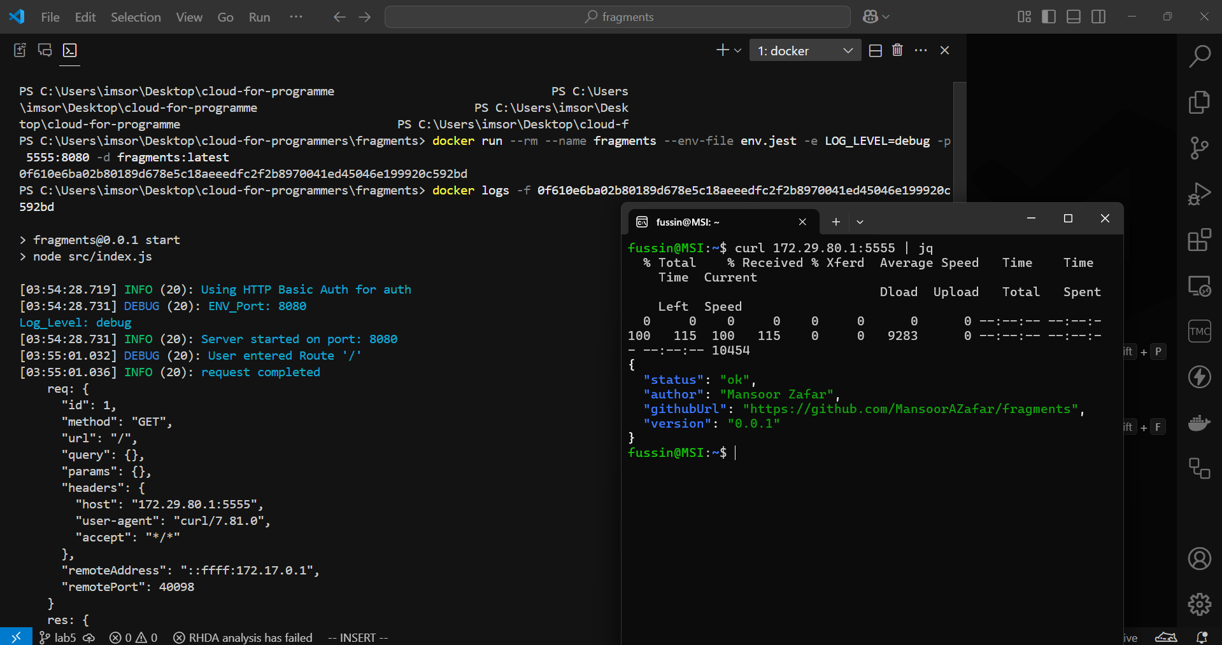

Fragments running in Visual Studio Code via Docker Extension + Logs
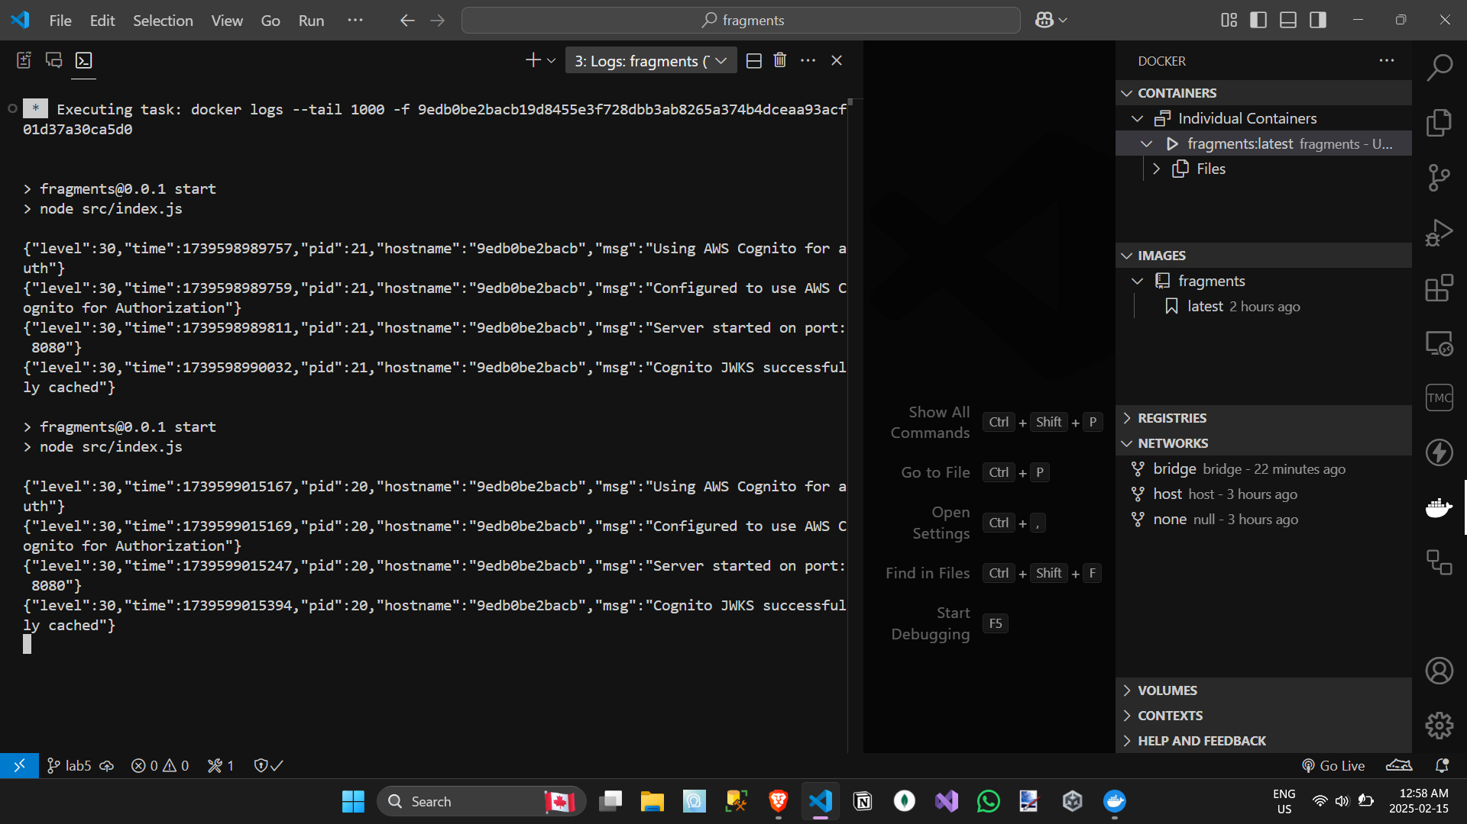

Fragments running as Docker container in detached mode on EC2, port 8080:8080 & server logs
